LAB 08:
Question#01:
CODE:
#include <iostream>
using namespace std;

class Vehicle
{
private:
string type;
string make;
string model;
string color;
int year;
double milesDriven;

public:
Vehicle(string type, string make, string model,
string color, int year, double miles)
: type(type), make(make), model(model),
color(color), year(year), milesDriven(miles) {}

string getType() const
{
return type;
}
string getMake() const
{
return make;
}
string getModel() const
{
return model;
}
string getColor() const
{
return color;
}
int getYear() const
{
return year;
}
double getMilesDriven() const
{
return milesDriven;
}

virtual void display() const
{
cout << "Type: " << type
<< " | Make: " << make
<< " | Model: " << model
<< " | Color: " << color
<< " | Year: " << year
<< " | Miles: " << milesDriven << "\n";
}

virtual ~Vehicle() {}
};

class GasVehicle : public Vehicle
{
private:
double fuelTankSize;

public:
GasVehicle(string type, string make, string model, string color,
int year, double miles, double tankSize)
: Vehicle(type, make, model, color, year, miles),
fuelTankSize(tankSize) {}

double getFuelTankSize() const
{
return fuelTankSize;
}

void display() const override
{
Vehicle::display();
cout << " Fuel Tank: " << fuelTankSize << "L\n";
}
};

class ElectricVehicle : public Vehicle
{
private:
double energyStorage;

public:
ElectricVehicle(string type, string make, string model, string color,
int year, double miles, double energy)
: Vehicle(type, make, model, color, year, miles),
energyStorage(energy) {}

double getEnergyStorage() const { return energyStorage; }

void display() const override
{
Vehicle::display();
cout << " Battery: " << energyStorage << " kWh\n";
}
};

class HighPerformance : public GasVehicle
{
private:
int horsePower;
double topSpeed;

public:
HighPerformance(string type, string make, string model, string color,
int year, double miles, double tankSize,
int hp, double topSpeed)
: GasVehicle(type, make, model, color, year, miles, tankSize),
horsePower(hp), topSpeed(topSpeed) {}

int getHorsePower() const { return horsePower; }
double getTopSpeed() const { return topSpeed; }

void display() const override
{
GasVehicle::display();
cout << " HP: " << horsePower << " | Top Speed: " << topSpeed << " km/h\n";
}
};

class HeavyVehicle : public GasVehicle, public ElectricVehicle
{
private:
double maxWeight;
int numberOfWheels;
double length;

public:
HeavyVehicle(string type, string make, string model, string color,
int year, double miles,
double tankSize, double energy,
double maxWeight, int wheels, double length)
: GasVehicle(type, make, model, color, year, miles, tankSize),
ElectricVehicle(type, make, model, color, year, miles, energy),
maxWeight(maxWeight), numberOfWheels(wheels), length(length) {}

double getMaxWeight() const { return maxWeight; }
int getNumberOfWheels() const { return numberOfWheels; }
double getLength() const { return length; }

void display() const override
{
GasVehicle::display();
cout << " Battery: " << ElectricVehicle::getEnergyStorage() << " kWh\n";
cout << " Max Weight: " << maxWeight << " tons"
<< " | Wheels: " << numberOfWheels
<< " | Length: " << length << " m\n";
}
};

class SportsCar : public HighPerformance
{
public:
string gearbox;
string driveSystem;

public:
SportsCar(string type, string make, string model, string color,
int year, double miles, double tankSize,
int hp, double topSpeed,
string gearbox, string driveSystem)
: HighPerformance(type, make, model, color, year, miles,
tankSize, hp, topSpeed),
gearbox(gearbox), driveSystem(driveSystem) {}

void display() const override
{
HighPerformance::display();
cout << " Gearbox: " << gearbox
<< " | Drive: " << driveSystem << "\n";
}
};

class ConstructionTruck : public HeavyVehicle
{
public:
string cargo; // cement, gravel, sand (public as per UML)

public:
ConstructionTruck(string type, string make, string model, string color,
int year, double miles,
double tankSize, double energy,
double maxWeight, int wheels, double length,
string cargo)
: HeavyVehicle(type, make, model, color, year, miles,
tankSize, energy, maxWeight, wheels, length),
cargo(cargo) {}

void display() const override
{
HeavyVehicle::display();
cout << " Cargo: " << cargo << "\n";
}
};

class Bus : public HeavyVehicle
{
private:
int numberOfSeats;

public:
Bus(string type, string make, string model, string color,
int year, double miles,
double tankSize, double energy,
double maxWeight, int wheels, double length,
int seats)
: HeavyVehicle(type, make, model, color, year, miles,
tankSize, energy, maxWeight, wheels, length),
numberOfSeats(seats) {}

int getNumberOfSeats() const { return numberOfSeats; }

void display() const override
{
HeavyVehicle::display();
cout << " Seats: " << numberOfSeats << "\n";
}
};

int main()
{

cout << "========== Bus ==========\n";
Bus bus(
"Public Transit","Volvo","B8R",
"Red", 2022, 45000.0, 200.0, 150.0, 18.0, 6, 12.5, 52);
bus.display();

cout << "\n========== Sports Car ==========\n";
SportsCar car("Coupe", "Ferrari","F40", "Red", 2023, 5000.0, 90.0, 478, 324.0, "Manual",
"Rear Wheel");
car.display();

cout << "========== Construction Truck ==========" << endl;
ConstructionTruck truck( "Heavy Duty", "Caterpillar", "CT660", "Yellow", 2021, 80000.0,
400.0, 0.0, 30.0, 10, 9.0, "Gravel");
truck.display();

return 0;
}
OUTPUT:
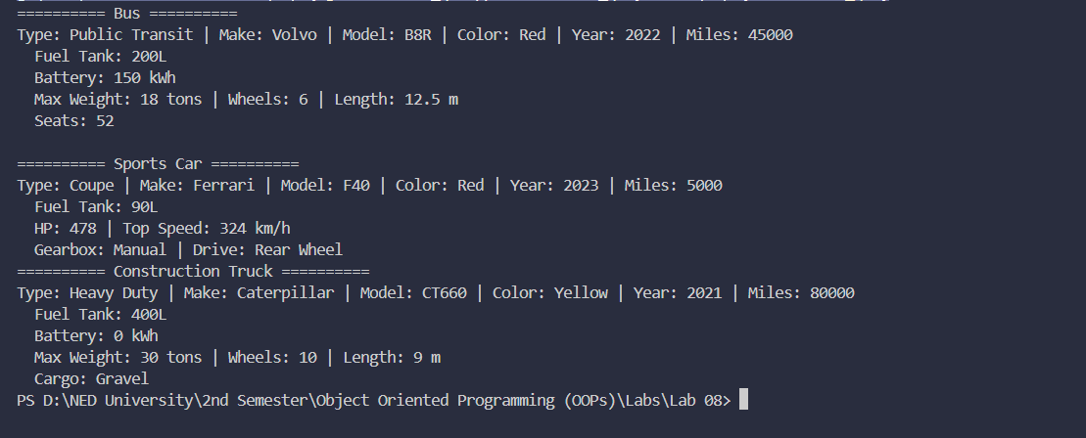

Question#02:
CODE:
#include <iostream>
using namespace std;

class Character {
protected:
string name;
int level;
int health;

public:
Character(string name, int level, int health)
: name(name), level(level), health(health) {}

virtual void attack() const {
cout << name << " attacks!\n";
}

virtual void display() const {
cout << "Name: " << name
<< " | Level: " << level
<< " | HP: " << health << "\n";
}

string getName() const { return name; }
int getLevel() const { return level; }
int getHealth()const { return health; }

virtual ~Character() {}
};

class Warrior : public Character {
protected:
int strength;
string meleeWeapon;

public:
Warrior(string name, int level, int health, int strength, string weapon)
: Character(name, level, health),
strength(strength), meleeWeapon(weapon) {}

void slash() const {
cout << name << " slashes with " << meleeWeapon
<< "! (Strength: " << strength << ")\n";
}

void attack() const override {
slash();
}

void display() const override {
Character::display();
cout << " [Warrior] Strength: " << strength
<< " | Weapon: " << meleeWeapon << "\n";
}
};

class Mage : public Character {
protected:
int intelligence;
string spellProficiency;

public:
Mage(string name, int level, int health, int intelligence, string spell)
: Character(name, level, health),
intelligence(intelligence), spellProficiency(spell) {}

void fireball() const {
cout << name << " casts Fireball! ("
<< spellProficiency << " magic, INT: " << intelligence << ")\n";
}

void attack() const override {
fireball();
}

void display() const override {
Character::display();
cout << " [Mage] Intelligence: " << intelligence
<< " | Spell: " << spellProficiency << "\n";
}
};

class Archer : public Character {
protected:
int dexterity;
string rangedWeapon;

public:
Archer(string name, int level, int health, int dexterity, string weapon)
: Character(name, level, health),
dexterity(dexterity), rangedWeapon(weapon) {}

void rapidShot() const {
cout << name << " fires Rapid Shot with " << rangedWeapon
<< "! (DEX: " << dexterity << ")\n";
}

void attack() const override {
rapidShot();
}

void display() const override {
Character::display();
cout << " [Archer] Dexterity: " << dexterity
<< " | Weapon: " << rangedWeapon << "\n";
}
};

class NPC : public Character {
private:
string movementPattern;
string dialogue;

public:
NPC(string name, int level, int health,
string movement, string dialogue)
: Character(name, level, health),
movementPattern(movement), dialogue(dialogue) {}

void move() const {
cout << name << " moves in pattern: " << movementPattern << "\n";
}

void speak() const {
cout << name << " says: \"" << dialogue << "\"\n";
}

void attack() const override {
cout << name << " (NPC) has no attack!\n";
}

void display() const override {
Character::display();
cout << " [NPC] Movement: " << movementPattern
<< " | Dialogue: \"" << dialogue << "\"\n";
}
};

class Mighty : public Warrior, public Mage {
private:
string title;

public:
Mighty(string name, int level, int health,
int strength, string weapon,
int intelligence, string spell,
string title)
: Warrior(name, level, health, strength, weapon),
Mage(name, level, health, intelligence, spell),
title(title) {}

void attack() const override {
cout << "=== " << title << " unleashes combined attack! ===\n";
slash();
fireball();
}

void display() const override {

cout << "Name: " << Warrior::name
<< " | Level: " << Warrior::level
<< " | HP: " << Warrior::health << "\n";
cout << " [Mighty - " << title << "]\n";
cout << " Strength: " << strength
<< " | Weapon: " << meleeWeapon << "\n";
cout << " Intelligence: " << intelligence
<< " | Spell: " << spellProficiency << "\n";
}

string getName() const { return Warrior::name; }
};

int main() {

cout << "========== Warrior ==========\n";
Warrior w("Aragorn", 10, 250, 85, "Sword");
w.display();
w.attack();
w.slash();

cout << "\n========== Mage ==========\n";
Mage m("Gandalf", 15, 180, 95, "Arcane");
m.display();
m.attack();
m.fireball();

cout << "\n========== Archer ==========\n";
Archer a("Legolas", 12, 200, 90, "Longbow");
a.display();
a.attack();
a.rapidShot();

cout << "\n========== NPC ==========\n";
NPC npc("Village Elder", 1, 50, "Patrol", "Beware the dark forest!");
npc.display();
npc.move();
npc.speak();

cout << "\n========== Mighty ==========\n";
Mighty mighty("Zephyros", 20, 400,
90, "Runic Axe",
88, "Fire",
"The Arcane Warlord");
mighty.display();
mighty.attack();

cout << "\n========== Polymorphism Demo ==========\n";

Character* party[] = { &w, &m, &a };
for (auto* c : party) {
cout << c->getName() << ": ";
c->attack();
}

return 0;
}

OUTPUT:
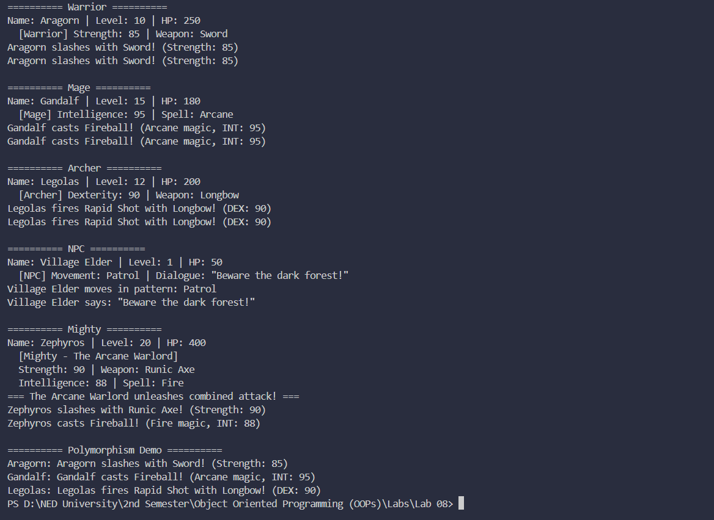

Question#03:
CODE:
#include <iostream>
using namespace std;

class Account {
protected:
double balance;

public:

Account() {
cout << "Enter initial balance: ";
cin >> balance;
}

// Parameterized constructor
Account(double balance) : balance(balance) {}

virtual void deposit(double amount) {
balance += amount;
cout << "Deposited: " << amount << " | New Balance: " << balance << "\n";
}

virtual void withdraw(double amount) {
if (amount > balance)
cout << "Insufficient funds!\n";
else {
balance -= amount;
cout << "Withdrawn: " << amount << " | New Balance: " << balance << "\n";
}
}

void checkBalance() const {
cout << "Balance: " << balance << "\n";
}

double getBalance() const { return balance; }

virtual ~Account() {} // Virtual Destructor.
};

class InterestAccount : public Account {
protected:
double interest;

public:

InterestAccount() : Account() {
cout << "Enter interest rate (default 0.30): ";
cin >> interest;
}

// Parameterized constructor
InterestAccount(double balance, double interest = 0.30)
: Account(balance), interest(interest) {}

void deposit(double amount) override {
double withInterest = amount + (amount * interest);
balance += withInterest;
cout << "Deposited: " << amount
<< " + Interest(" << interest * 100 << "%): " << amount * interest
<< " | New Balance: " << balance << "\n";
}
};

class ChargingAccount : public Account {
protected:
double fee;

public:

ChargingAccount() : Account() {
cout << "Enter withdrawal fee (default 25): ";
cin >> fee;
}

// Parameterized constructor
ChargingAccount(double balance, double fee = 25.0)
: Account(balance), fee(fee) {}

void withdraw(double amount) override {
double total = amount + fee;
if (total > balance)
cout << "Insufficient funds (amount + fee Rs." << fee << ")!\n";
else {
balance -= total;
cout << "Withdrawn: " << amount
<< " + Fee: " << fee
<< " | New Balance: " << balance << "\n";
}
}
};

class ACI : public InterestAccount, public ChargingAccount {
public:
// Default constructor — takes user input
ACI() {
cout << "\n-- ACI Account Setup --\n";
cout << "Enter balance: ";
// balance is ambiguous
cin >> InterestAccount::balance;
ChargingAccount::balance = InterestAccount::balance;

cout << "Enter interest rate (default 0.30): ";
cin >> interest;

cout << "Enter withdrawal fee (default 25): ";
cin >> fee;
}

// Parameterized constructor
ACI(double balance, double interest = 0.30, double fee = 25.0)
: InterestAccount(balance, interest),
ChargingAccount(balance, fee) {}

void deposit(double amount) override {
InterestAccount::deposit(amount);
ChargingAccount::balance = InterestAccount::balance;
}

void withdraw(double amount) override {
ChargingAccount::withdraw(amount);
InterestAccount::balance = ChargingAccount::balance;
}

void checkBalance() const {
cout << "Balance: " << InterestAccount::balance << "\n";
}

void transfer(double amount, Account& target) {
if (amount > InterestAccount::balance) {
cout << "Insufficient funds for transfer!\n";
return;
}
InterestAccount::balance -= amount;
ChargingAccount::balance = InterestAccount::balance;
target.deposit(amount);
cout << "Transferred " << amount << " to Account.\n";
}

void transfer(double amount, InterestAccount& target) {
if (amount > InterestAccount::balance) {
cout << "Insufficient funds for transfer!\n";
return;
}
InterestAccount::balance -= amount;
ChargingAccount::balance = InterestAccount::balance;
target.deposit(amount); // deposit with interest applied
cout << "Transferred " << amount << " to InterestAccount (with interest).\n";
}

void transfer(double amount, ChargingAccount& target) {
if (amount > InterestAccount::balance) {
cout << "Insufficient funds for transfer!\n";
return;
}
InterestAccount::balance -= amount;
ChargingAccount::balance = InterestAccount::balance;
target.deposit(amount);
cout << "Transferred " << amount << " to ChargingAccount.\n";
}
};

int main() {

cout << "======= Interest Account =======\n";
InterestAccount ia(1000, 0.30);
ia.checkBalance();
ia.deposit(500);
ia.checkBalance();
ia.withdraw(200);
ia.checkBalance();

cout << "\n======= Charging Account =======\n";
ChargingAccount ca(1000, 25);
ca.checkBalance();
ca.deposit(300);
ca.checkBalance();
ca.withdraw(200);
ca.checkBalance();

cout << "\n======= ACI Account =======\n";
ACI aci(5000, 0.30, 25);
aci.checkBalance();
aci.deposit(1000);
aci.checkBalance();
aci.withdraw(500);
aci.checkBalance();

cout << "\n-- Transfer to generic Account --\n";
Account plain(2000);
plain.checkBalance();
aci.transfer(300, plain);
plain.checkBalance();

cout << "\n-- Transfer to InterestAccount --\n";
InterestAccount ia2(500, 0.30);
ia2.checkBalance();
aci.transfer(400, ia2);
ia2.checkBalance();

cout << "\n-- Transfer to ChargingAccount --\n";
ChargingAccount ca2(800, 25);
ca2.checkBalance();
aci.transfer(200, ca2);
ca2.checkBalance();

return 0;
}

OUTPUT:
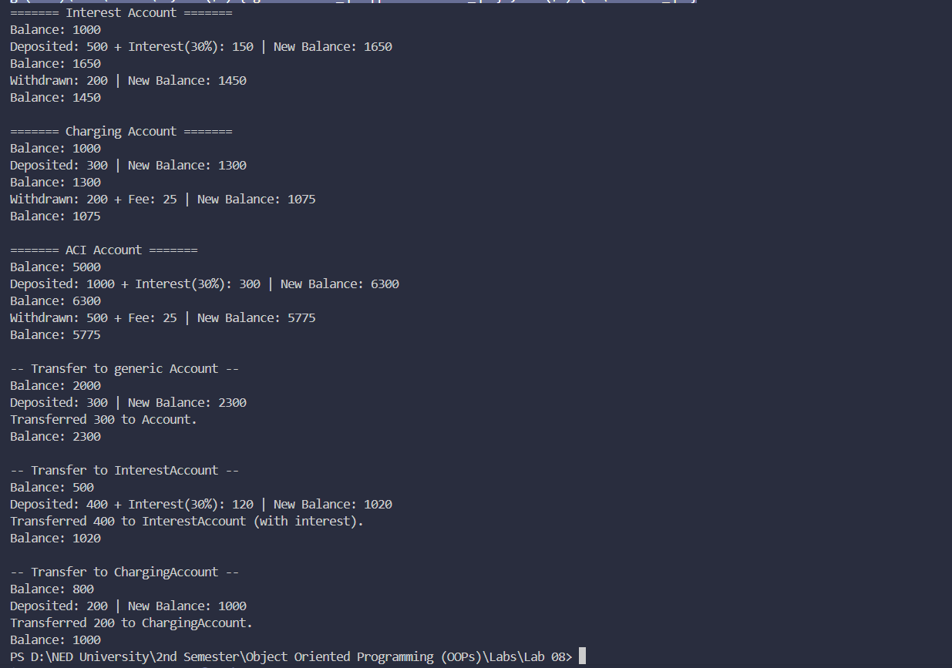

Question#04:
CODE:
#include <iostream>
using namespace std;

class Media {
protected:
string title;
int year;
bool isBorrowed;

public:
Media(string title, int year)
: title(title), year(year), isBorrowed(false) {}

void borrow() {
if (isBorrowed)
cout << "\"" << title << "\" is already borrowed!\n";
else {
isBorrowed = true;
cout << "\"" << title << "\" has been borrowed.\n";
}
}

void returnMedia() {
if (!isBorrowed)
cout << "\"" << title << "\" was not borrowed!\n";
else {
isBorrowed = false;
cout << "\"" << title << "\" has been returned.\n";
}
}

virtual void display() const {
cout << "Title: " << title
<< " | Year: " << year
<< " | Status: " << (isBorrowed ? "Borrowed" : "Available") << "\n";
}

virtual ~Media() {}
};

class BookAttributes {
protected:
string author;
string genre;
int pages;

public:
BookAttributes(string author, string genre, int pages)
: author(author), genre(genre), pages(pages) {}
};

class MagazineAttributes {
protected:
int issueNumber;
string publisher;

public:
MagazineAttributes(int issueNumber, string publisher)
: issueNumber(issueNumber), publisher(publisher) {}
};

class DVDAttributes {
protected:
string director;
double duration;

public:
DVDAttributes(string director, double duration)
: director(director), duration(duration) {}
};

class Book : public Media, public BookAttributes {
public:
Book(string title, int year, string author, string genre, int pages)
: Media(title, year),
BookAttributes(author, genre, pages) {}

void display() const override {
Media::display();
cout << " [Book] Author: " << author
<< " | Genre: " << genre
<< " | Pages: " << pages << "\n";
}
};

class Magazine : public Media, public MagazineAttributes {
public:
Magazine(string title, int year, int issueNumber, string publisher)
: Media(title, year),
MagazineAttributes(issueNumber, publisher) {}

void display() const override {
Media::display();
cout << " [Magazine] Issue: " << issueNumber
<< " | Publisher: " << publisher << "\n";
}
};

class DVD : public Media, public DVDAttributes {
public:
DVD(string title, int year, string director, double duration)
: Media(title, year),
DVDAttributes(director, duration) {}

void display() const override {
Media::display();
cout << " [DVD] Director: " << director
<< " | Duration: " << duration << " mins\n";
}
};

int main() {

cout << "========== Library System ==========\n\n";

Book b("The Hobbit", 1937, "J.R.R. Tolkien", "Fantasy", 310);
Magazine mag("National Geographic", 2023, 215, "Nat Geo Partners");
DVD dvd("Inception", 2010, "Christopher Nolan", 148);

cout << "-- Library Catalog --\n";
b.display();
mag.display();
dvd.display();

cout << "\n-- Borrowing --\n";
b.borrow();
dvd.borrow();
b.borrow();

cout << "\n-- Updated Status --\n";
b.display();
dvd.display();

cout << "\n-- Returning --\n";
b.returnMedia();
dvd.returnMedia();
dvd.returnMedia();

cout << "\n-- Final Status --\n";
b.display();
mag.display();
dvd.display();

cout << "\n-- Polymorphism Demo --\n";
Media* library[] = { &b, &mag, &dvd };
for (auto* item : library) {
item->display();
cout << "\n";
}

return 0;
}

OUTPUT:
